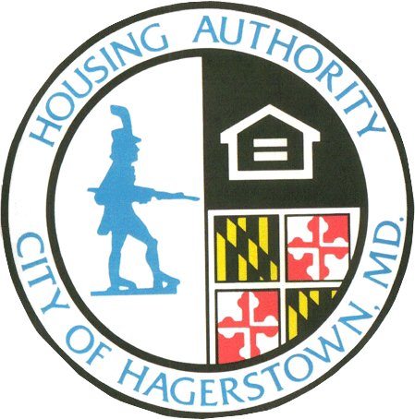C:\Users\hhooper.HHA\AppData\Local\Microsoft\Windows\Temporary Internet Files\Content.IE5\QKR833J2\MC900020667[1].wmfC:\Users\hhooper.HHA\AppData\Local\Microsoft\Windows\Temporary Internet Files\Content.IE5\QKR833J2\MC900020667[1].wmf

As stated in the Policy for Safety and Security, the participant is obligated “to keep our program participants free from threats to their personal and family safety” and “to help maintain a safe and drug-free community environment where families can live safely, free of the dangers associated with illegal drug activity.” Any such activity by any household member could result in a Notice of Termination of Assistance. Any drug-related activity by any household member on or off premises is often referred to as HUD’s One Strike Policy and is defined by HUD Regulations and HHA Policy. All Section 8 participants sign a copy of this policy annually to certify their understanding. As stated in HUD Regulation 982.533 the Housing Authority may deny or terminate assistance to a participant, regardless of whether they have been arrested or convicted. A criminal conviction or arrest is not necessary, and the Housing Authority need not meet the criminal standard of proof beyond a reasonable doubt in terminating program assistance. Criminal activity is cause for termination of assistance even in the absence of conviction or arrest.



# HUD Regulation-Policy for Safety and Security

The Housing Authority will be closed on the following Holidays:

November 11, 2020 Veteran’s Day

November 26 & 27, 2020 ThanksgivingC:\Users\hhooper.HHA\AppData\Local\Microsoft\Windows\Temporary Internet Files\Content.IE5\QKR833J2\MC900151715[1].wmf

**REMINDERS**

* **Take advantage of Rent Café, email and the Drop Box to report changes and deliver documents to us.**
* **If you want to move, you must give a 30-day notice to your landlord and your Housing Specialist. Have a place in mind before you give notice so it will be a smooth transition.**
* **Double check to make sure all documents are signed, filled out completely and verifications are included before returning your mail out recertification.**
* **Be prepared and home for biennial inspections. Your unit must pass in order for assistance to continue.**

HCV Newsletter

### HCV Department

Sharon Deneen [sdeneen@hagerstownha.com](mailto:sdeneen@hagerstownha.com) Ext. 152

Angie Albaugh [aalbaugh@hagerstownha.com](mailto:aalbaugh@hagerstownha.com) Ext. 151

Liz Donovan [ldonovan@hagerstownha.com](mailto:ldonovan@hagerstownha.com) Ext. 184

Holly Hooper [hhooper@hagerstownha.com](mailto:hhooper@hagerstownha.com) Ext. 123

Tacy Myers, FSS [tmyers@hagerstownha.com](mailto:tmyers@hagerstownha.com) Ext. 157

Inspector:

Don Harkcom [dharkcom@hagerstownha.com](mailto:dharkcom@hagerstownha.com) Ext. 161

301-733-6911 P 301-745-4894 F

Fall 2020

**Housing Quality Standards**

We have seen an increase in the number of Section 8 contracts being terminated for failing to comply with the Housing Quality Standards (HQS) and complete repairs in a timely manner by both Tenants and Owners/Landlords. Under Section 982.404 of the federal regulations, several items are clear, “The Owner must maintain the unit in accordance with HQS”” and “if the owner fails to maintain the dwelling unit in accordance with HQS, the PHA must take prompt and vigorous action to enforce the owner obligations.” The same regulations go on to say that the family responsible for HQS fails that are caused by the family’s failure to pay for utilities and appliances not provided by the landlord and damages beyond wear and tear. Failure to complete the repairs can result in abatement of the rent along with termination of the contract.

When inspections are conducted, the inspector determines the time frame in which repairs must be completed, however all repairs must be completed within 30 days of any Housing Authority approved extension. A termination notice is not an extension of time to complete repairs.

Due to cuts in funding and the administrative fees earned to run the Section 8 program, we can no longer afford to conduct more than two inspections—an initial and a re-inspection.

We truly recognize the importance of our landlords and the necessary services we provide to our participants and by minimizing program costs, we are able to continue to do what we do.

It’s that time of the year to make sure that your heating system is working properly and efficiently. Heating season begins October 1st and ends May 15th. Please read the following carefully to help increase efficiency and decrease hazards.

1. Do not supplement heat by using an oven, kerosene heater or other non-vented heaters. Using supplemental heat is a violation of the Section 8 Program.
2. Shut all storm windows to prevent heat loss.
3. Do no store flammable/combustibles such as mowers, gas cans, & cardboard boxes near or against the furnace or water heater.
4. Test smoke detectors monthly & install new batteries every 6 months or whenever a smoke detector chirps to indicate low batteries.
5. NEVER leave a stove unattended when cooking.
6. Extensions cords may not be used as permanent wiring. Do not run extension cords under doorways or rugs.

**Inspector’s Corner**

# Drawing Readers to Other Articles

The Hagerstown Housing Authority's Family Self-Sufficiency (FSS) Program offers employment and other case management services designed to promote economic self-sufficiency for families and individuals participating in the Housing Choice Voucher (HCV) and Public Housing (PH) Programs. The voluntary FSS Program assists participants to develop specific economic goals via their individual goal plan, and work with an FSS Coordinator to identify activities and services to help achieve these goals over a five-year period.

One of the benefits of the FSS program is an interest-bearing escrow account that is established by the Housing Authority in the name of each participating family. An escrow credit is based on increases in earned income that is credited to this account by the housing authority during the term of the FSS contract. Upon fulfillment of the five-year program and completion of the goals listed on the goal plan, families receive the funds in the escrow account.

FSS Coordinators are available to help families access a host of other career, training and community services as well. FSS program services may include, but are not limited to:

 Assistance in identifying and reaching goals within a specific time frame

 Referrals to community supportive services

* Informational and educational workshops

 Support and encouragement with the transition from government assistance to being financially independent

 Provide referrals to substance/alcohol abuse treatment or counseling

* Explore homeownership

If you are interested in learning more about the FSS Program please contact one of the FSS Coordinators at 301-733-6911 (ext. 157) Tacy Myers, (ext. 158) Kelly MillsThompson or (ext. 167) Pam Schnebly.

Family Self-Sufficiency Program

 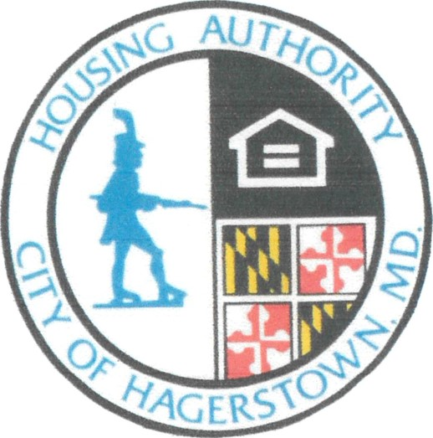

Maryland Energy Assistance

The Maryland Energy Assistance Program (MEAP) is an income eligible program designed to help Maryland citizens pay their heating bills, minimize heating crisis, and make energy costs more affordable. It provides grants in the form of payments made directly to the resident’s fuel supplier on behalf of the resident. The grant will not pay for the entire bill, but only a portion of it. For further information contact Community Action Council at 117 Summit Ave. Hagerstown MD 21740  
  
**TEL:** 301-797-4161  
**HOURS:** Monday thru Friday,  
8:30am–4:00pm  
**EMAIL:** [info@wccac.org](mailto:info@wccac.org)



Rent Increases

Must be submitted in writing to the tenant and the Housing Authority 60 days before the effective date. They should coincide with the tenant recertification date. A new lease is not required by our agency for rent increases. The tenant’s HCV Specialist will let you know if the amount you requested is NOT approved. If it is approved, you will see the increase on the effective date. 

A retro rent is money you have to pay back to the Housing Authority when your rent should have increased as a result of a change in income or family size. Avoid retros by reporting your income and family size changes with in 14 days of occurrence! A retro rent could also cause you to lose your Section 8. Please report all changes on time!